**15TH EIASM WORKSHOP ON FAMILY FIRM MANAGEMENT RESEARCH**

**FAMILY ENTREPRENEURSHIP AND SOCIETY**

NANTES, FRANCE, MAY 23-25

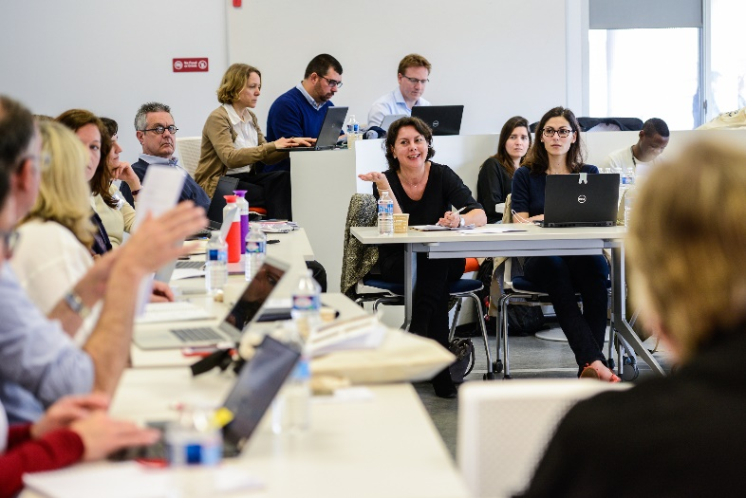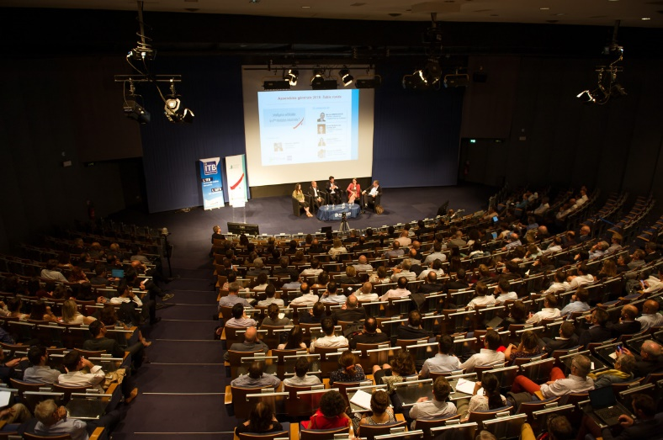



**Thursday, May 23, 2019:**

19:00 : Welcome reception - in conjunction with [STEP Europe Meeting](https://entrepreneuriat-familial.audencia.com/articles/evenement/step-meeting-22-23-mai-2019/?no_cache=1&cHash=53088a0b90fc10158cbc547eba5305fc)

Musée des Arts de Nantes, Nantes (see p. 12)

**Friday, May 24, 2019:**

Venue: Audencia Business School Atlantic Campus

08:30 – 9:00: Registration

9:00 – 9:15 Welcome by Vice Dean and Academic Director of Audencia and Chairs of Conference, *Amphi Edit de Nantes*

9:15-10:00: Keynote Speech by Laura J. Spence

**“A sorry tale? Family business, SMEs and the SDGs”**

*Amphi Edit de Nantes*

10:00-10:30: Group photo, coffee break in the Forum

10:30-12:00: Parallel Sessions 1, 2 and 3

|  |  |  |
| --- | --- | --- |
| **Session 1 Room Learning Lab**  Topic: Corporate Social Responsibility- Chair: Laura Spence | | |
| **Title** | **Author** | **Co-Author(s)** |
| FAMILY FIRM SOCIAL RESPONSIBILITY:  MAPPING LITERATURE AND DRAWING FUTURE RESEARCH AGENDA | CAMPOPIANO, GIOVANNA | SALVATORE SCIASCIA  PIETRO MAZZOLA |
| DETERMINANTS OF SUSTAINABLE BEHAVIOR | DIAZ-MATAJIRA, LUIS | NUNZIA AULETTA, ANA GONZÁLEZ, YENY RODRIGUEZ |
| CSR OF FAMILY FIRMS IN TOURISM – THE INTERACTION BEHAVIOUR BETWEEN FAMILY FIRMS AND DESTINATION MANAGEMENT ORGANIZATIONS | ZEHRER, ANITA | GUNDULA GLOWKA |
|  |  |  |
| **Session 2 Room 235**  Topic: Entrepreneurial Orientation- Chair: Jonathan Bauweraerts | | |
| **Title** | **Author** | **Co-Author(s)** |
| OWNERSHIP SUCCESSION FINANCING AND TEMPORAL FOCUS: EXPLAINING THE ENTREPRENEURIAL ORIENTATION OF NEXT-GENERATION FAMILY FIRMS | JANSSEN, ELLEN | SIGRID VANDEMAELE  WIM VOORDECKERS  MARK VANCAUTEREN |
| HOW THE FAMILY NATURE OF THE COMPANY AFFECTS THE RELATIONSHIP BETWEEN POLICIES TO SUPPORT INNOVATION AND ENTREPRENEURIAL ORIENTATION? AN EMPIRICAL STUDY IN MEXICO | LÓPEZ-FERNÁNDEZ, MARIA CONCEPCION | L. YENIRA TLACUILO-PARRA, REMEDIOS HERNÁNDEZ-LINARES |
|  |  |  |
| **Session 3 Room 237**  Topic: Past and Futures of the Family Firm- Chair: Ethel Brundin | | |
| **Title** | **Author** | **Co-Author(s)** |
| LOOKING FORWARD OR TAPPING INTO PAST EXPERIENCE:  FAMILY FIRMS’ LONG-TERM ORIENTATION AND TRADITIONS AS DRIVERS OF COMPANY PERFORMANCE | BROEKAERT, WOUTER | BART HENSSEN  JOHAN LAMBRECHT |
| HOW IMPRINTS SHAPE WILLING SUCCESSORS: EVIDENCE FROM CENTENNIAL FAMILY FIRMS | BUSQUET SEGUÍ, FRANCESC | PILAR MARQUÈS,  ANDREA BIKFALVI |

12:00 – 13:30: Parallel sessions 4, 5 and 6

|  |  |  |
| --- | --- | --- |
| **Session 4 Room Learning Lab**  Topic: Governance: Boards of Directors - Chair: Stephan Prigge | | |
| **Title** | **Author** | **Co-Author(s)** |
| THE DARK SIDE OF TWO-TIERS BOARDS IN CONTINENTAL EUROPE SOCIETIES FOR FAMILY BUSINESS: A RENEWAL OF ENTRENCHMENT MECHANISMS | BARREDY, CÉLINE |  |
| EXPLORING THE INTERNATIONALIZATION–PERFORMANCE RELATIONSHIP IN PRIVATE FAMILY FIRMS: DO BOARD TASKS MATTER? | BAUWERAERTS, JONATHAN |  |
| FAMILY-MANAGED FIRMS AND LOCAL EXPORT SPILLOVER | BASCO, RODRIGO | STEFANO AMATO  NICOLA LATTANZ |
|  |  |  |
| **Session 5 Room 235**  Topic: Religion - Chair: Maria José Parada | | |
| **Title** | **Author** | **Co-Author(s)** |
| CATHOLIC VALUES AND CORPORATE SOCIAL RESPONSIBILITY  THREE CASES FROM LATIN AMERICAN FAMILY FIRMS | CORONADO, FREDDY | JULIO HERNANDEZ PAJARES  LISSETH VASQUEZ PEÑALOZA |
| HOW RELIGIOUS FAITH CAN BE A SOURCE OF COMPETITIVE ADVANTAGE FOR FAMILY FIRMS: AN EXEMPLAR FROM THE UNITED KINGDOM | DISCUA CRUZ, ALLAN FERNANDO | NICHOLAS WONG  ANDREW SMITH  NICHOLAS BURTON |
|  |  |  |
| **Session 6 Room 237**  Topic: Social Capital - Chair: Eddy Laveren | | |
| **Title** | **Author** | **Co-Author(s)** |
| INTERNAL SOCIAL CAPITAL IN FAMILY FIRMS: AN EMPIRICAL ANALYSIS | BARROS, ISMAEL | VÍCTOR TEMPRANO GARCÍA  ANA ISABEL RODRÍGUEZ ESCUDERO  JAVIER RODRÍGUEZ PINTO |
| FAMILY SOCIAL CAPITAL AT THE NEXUS BETWEEN FINANCIAL DISASTER AND SMALL FAMILY FIRM ADAPTATION | SCHOLES, MAHALA | ELIAS HADJIELIAS  PEGGY ALEXOPOULOU  MATHEW HUGHES |
| EXPLORING THE MEDIATION ROLE OF SOCIAL SKILLS IN FAMILY FIRMS: THE IMPACT OF SOCIAL CAPITAL | YEZZA, HEDI | DIDIER CHABAUD |

13:30 – 14:30: Lunch @ school in the Forum

14:30 – 16:00: Parallel sessions 7, 8 and 9

|  |  |  |
| --- | --- | --- |
| **Session 7 Room 235**  Topic: Transgenerational Entrepreneurship - Chair: Luis Diaz Matajira | | |
| **Title** | **Author** | **Co-Author(s)** |
| FAMILY VALUES AS RESOURCE FOR SUCCESSFUL TRANSGENERATIONAL ENTREPRENEURSHIP IN A TRANSITION ECONOMY | NAZAROV, MIKHAIL | ILSE A. MATSER |
| LEARNING THROUGH THE GENERATIONS: EXAMINING FAMILY BUSINESS SURVIVAL THROUGH A LEARNING LENS | ELLIOTT, CAROLE | LOUISE SCHOLES  MICHAEL MUSTAFA |
| FAMILY FARM SUCCESSION: A FOCUS ON SUCCEEDING AND NON-SUCCEEDING SIBLINGS | MATSER, ILSE | JELLE BOUMA,ERIK VELDHUIZEN |
|  |  |  |
| **Session 8 Room Learning Lab**  Topic: Corporate Venturing - Chair: Mattias Nordqvist | | |
| **Title** | **Author** | **Co-Author(s)** |
| DYNAMIC INFLUENCES OF FAMILY CAPITAL ON CORPORATE VENTURING IN FAMILY FIRMS | NAZIR, IMRAN | ETHEL BRUNDIN  LEIF MELIN |
| CORPORATE SOCIAL VENTURING BY FAMILY OWNED BUSINESSES IN EMERGING AND DEVELOPING COUNTRIES | RAMIREZ-PASILLAS, MARCELA | HANS LUNDBERG |
| A THEORY OF VENTURE CAPITAL FAMILY BUSINESS (VCFB): PROFESSIONALIZATION TRAJECTORIES | LJUNGKVIST, TORBJORN | BÖRJE BOERS |
|  |  |  |
| **Session 9 Room 237**  Topic: CEO / Owner characteristics and interactions - Chair: Allan Fernando Discua Cruz | | |
| **Title** | **Author** | **Co-Author(s)** |
| CHALLENGES OF BUILDING A POSITIVE OWNER IDENTITY | PLATE, MARKUS |  |
| SOCIAL IDENTITY AND FAMILY OWNED BANKS: EXPLORING THE ROLE OF IDENTITY IN FAMILY PHILANTHROPY | LIMA, LUCIANA LUCENA DE | MARIA JOSÉ PARADA |
| DO CEO INDIVIDUAL CHARACTERISTICS MATTER FOR FINANCIAL PERFORMANCE OF A FIRM?  THE CASE OF RUSSIAN MANUFACTURING ENTERPRISES | GOLIKOVA, VICTORIA | BORIS KUZNETSOV |

16:00 – 16:30: Coffee break in the Forum

16:30 – 17:30: Topical breakout sessions – 4 sessions

Room 235

1. **Meet the editors:** “RESPONSIBLE OWNERSHIP IN FAMILY FIRMS: A FOCUS ON THE FAMILY”, special issue of the *Journal of Family Business Management*: Luis Diaz Matajira, Kathleen Randerson.

Room 237

1. **Meet the editors:** “FAMILY ENTREPRENEURSHIP IN COMMUNITIES: SOCIAL CONTEXT AND THE CREATION OF SOCIAL VALUE”, special issue of the*Journal of Enterprising Communities: People & Places in the Global Economy*: Claire Seaman.

Learning lab

1. **PhD tips-n-tricks to survive or even thrive**

A topical session for PhD and very early career scholars.   
Mediators: Eddy Laveren (senior scholar), Maria José Parada (mid-career scholar) and Josh  
Hsueh (very engaged young scholar).

Salle Le Forum

1. **Meet-and-greet journal editors**

Andreas Scherer: Associate Editor of *Business Ethics Quarterly*

Andrea Calabro: Associate Editor of *Journal of Family Business Strategy*

Alfredo De Massis: Associate Editor of *Family Business Review*

Rania Labaki: editor-in-chief of *Entrepreneurship Research Journal*

19:30 - 22:30: Gala Dinner at Vertigo, Nantes (see p. 13)

**Saturday, May 25, 2019:**

9:00 – 10:30: Parallel sessions 10, 11 and 12

|  |  |  |
| --- | --- | --- |
| **Session 10 Room Learning Lab**  Topic: Governance- Chair: Céline Barrédy | | |
| **Title** | **Author** | **Co-Author(s)** |
| CAN INFORMATION, ORGANIZATION PRACTICES AND GOVERNMENT STRUCTURES AT FAMILY AND FIRMS LEVELS MODULATE THE IMPACT OF COMPLEXITY ON ROA? | CLEMENTE-ALMENDROS, JOSÉ ANTONIO | CÉSAR CAMISÓN-ZORNOZA  ALBA PUIG-DENIA  TOMÁS GONZÁLEZ-CRUZ |
| UNDERSTANDING THE FAMILY CONSTITUTION: UNDERSTANDING DRIVERS FOR ITS DEVELOPMENT AND IMPLEMENTATION | PRIGGE, STEFAN | ISABEL C. BOTERO |
| THE RELATIONSHIP BETWEEN FAMILY OWNERSHIP DISPERSION AND R&D INVESTMENTS IN PRIVATE FAMILY FIRMS: THE MODERATING ROLE OF MARKET TURBULENCE | BAUWERAERTS, JONATHAN |  |
|  |  |  |
| **Session 11 Room 235**  Topic: Innovation - Chair: Pilar Marquez | | |
| **Title** | **Author** | **Co-Author(s)** |
| EXPLORING THE ROLE OF COLLABORATIVE FAMILINESS AND CONSTRUCTIVE CONFLICT MANAGEMENT IN INNOVATION ACTIVITIES OF FAMILY FIRMS | ALVARADO-ALVAREZ, CRISTINA | MARÍA JOSÉ PARADA  IMMACULADA ARMADANS |
| INNOVATION IN FAMILY FIRMS AN IRISH PERSPSECTIVE | MURPHY, LINDA | DR GERALINE RYAN  DR JUSTIN DORAN |
| FAMILY TIES AND INVOLVEMENT IMPACT ON INNOVATION PROCESS IN HIGH-TECH FIRMS. | KHMELEVA, POLINA | STEPANOVA ANASTASIA NIKOLAEVNA |
|  |  |  |
|  |  |  |
| **Session 12 Room 237**  Topic: Succession/ NextGen Perspective - Chair: Leif Melin | | |
| **Title** | **Author** | **Co-Author(s)** |
| EXPLORING SOCIAL INNOVATION IN THE FAMILY BUSINESS FROM A NEXT GENERATION PERSPECTIVE | LABAKI, RANIA |  |
| THE ART OF FAMILY BUSINESS SUCCESSION: THE NARRATIVE OF A THIRD GENERATION | LOBO, KRISTINE GAIL | ANDREA SANTIAGO  ALLANNE MAE TIONGCO  KENNETH METRADO |

10:30 – 11:00: Coffee break in the Forum

11:00 – 11:45: Keynote Speech by Alfredo De Massis

**“Trends, challenges and opportunities in family entrepreneurship research”**

*Amphi Edit de Nantes*

11:45 – 13:15: Parallel sessions 13, 14

|  |  |  |
| --- | --- | --- |
| **Session 13 Room Learning Lab**  Topic: Knowledge/Learning - Chair: Elias Hadjielias | | |
| **Title** | **Author** | **Co-Author(s)** |
| COMPETING FORCES IN THE SOCIAL RELATIONSHIPS IN FAMILY FIRMS:  A REVIEW OF THE LITERATURE | MISMETTI, MARCO | BETTINELLI CRISTINA  BERGAMASCHI MARA |
| FAMILY RELATIONSHIPS AND FAMILY FIRMS’ ORGANIZATIONAL LEARNING  AN EXPLORATORY STUDY | VINCENT, JULIA | CHARLES-HENRI BESSEYRE-DES-HORTS |
| THE OCCURRENCE, MECHANISMS AND BOUNDARY CONDITIONS OF KNOWLEDGE HIDING IN FAMILY BUSINESS | BERNATOVIC, IVIJA | ALENKA SLAVEC GOMEZEL  MATEJ CERNE |

|  |  |  |
| --- | --- | --- |
|  |  |  |
| **Session 14 Room 237**  Topic: Family Embeddedness Perspective and associated challenges - Chair: Josh Hsueh | | |
| **Title** | **Author** | **Co-Author(s)** |
| FAMILY EMBEDDEDNESS PERSPECTIVE: LITERATURE REVIEW | VASILEVSKA, KATERINA |  |
| WORK-FAMILY INTERFACE: COPING STRATEGIES IN GROWING FAMILY SMES | BOERS, BÖRJ | DANILO BROZOVIC |
| THE ELUDED SUCCESSION. PSYCHOLOGICAL FRAMEWORKS EXPLAINING THE RESISTANCE TO RETIREMENT AMONG (VERY) OLD ENTREPRENEURS | FERRARI, FILIPPO |  |

13:15 – 14:15: Lunch @ school in the Forum

14:15 – 15:45: Parallel sessions 15, 16 and 17

|  |  |  |
| --- | --- | --- |
| **Session 15 Room 237**  Topic: Internationalization / Globalization - Chair: Andrea Clabro | | |
| **Title** | **Author** | **Co-Author(s)** |
| RELATIONSHIP BETWEEN INNOVATION AND GLOBAL FIRM.  MEDIATING AND MODERATING EFFECTS IN THE FAMILY BUSINESS. | ROJAS VAZQUEZ, ALVARO | DANIEL LORENZO  ANDREAS KALLMUENZER |
| BOARD INDEPENDENCE AND CORPORATE REPUTATION. FAMILY VERSUS NON-FAMILY FIRMS | MARTÍN ZAMORA, MARÍA PILAR | MARÍA JESÚS MORENO-DOMÍNGUEZ  ISABEL SERRANO-CZAIA  LÁZARO RODRÍGUEZ-ARIZA |
| FAMILY FIRMS’ FINANCING HETEROGENEITY ACROSS COUNTRIES | FEITO-RUIZ, ISABEL | SUSANA MENÉNDEZ-REQUEJO |
|  |  |  |
| **Session 16 Room 235**  Topic: Strategies and operations - Chair: Ilse Matser | | |
| **Title** | **Author** | **Co-Author(s)** |
| FAMILY BUSINESS ADVISING, STRATEGIC WORK AND UNFOLDING SPACES | QUARCHIONI, SONIA | ROBERTA CICCOLA  MARIA SERENA CHIUCCHI |
| BRAND DELETION DECISION-MAKING IN FAMILY FIRMS: A SOCIOEMOTIONAL WEALTH APPROACH | BARROS, ISMAEL | VÍCTOR TEMPRANO GARCÍA  ANA ISABEL RODRÍGUEZ ESCUDERO  JAVIER RODRÍGUEZ PINTO |
|  |  |  |
| **Session 17 Room Learning Lab**  Topic: Affect/Identity/Stewardship - Chair: Giovanna Campopiano | | |
| **Title** | **Author** | **Co-Author(s)** |
| FAMILY FIRMS AND CSR: THE IMPORTANCE OF THE AFFECTIVE ASPIRATIONS | KURAK, MALGORZATA | JORDI SURROCA  PETER VOGEL |
| ENTREPRENEURIAL STEWARDSHIP AND FAMILY BUSINESSES: THE CASE OF COFFEE FAMILY FARMS IN CENTRAL AMERICA | DISCUA CRUZ, ALLAN FERNANDO | LEONARDO CENTENO-CAFFARENA  MARCO VEGA SOLANO |

16:00 – 16:15: Flag to next year, A170, 1st floor ECE building



TO REACH AUDENCIA BUSINESS SCHOOL

**Audencia Business School**

8, route de la Jonelière – BP 31222 – 4

4312 Nantes Cedex 3 France

Tél: + 00 33 (0) 2 40 37 34 34

Tram Line 2—Ecole centrale-Audencia Stop

* 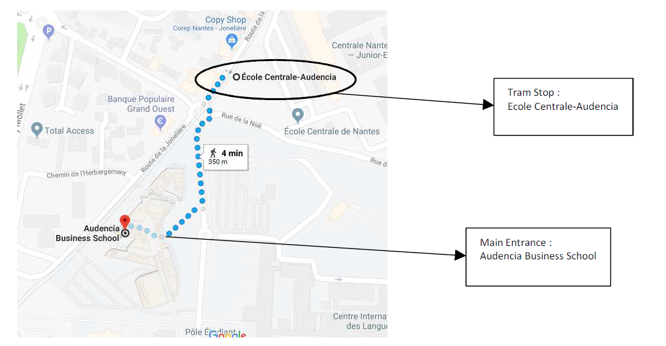Access to the Main Entrance of Audencia Business School (please note that due to increased security measures, the campus is only accessible via the Main Entrance )

**From the railway station**

Tram line 1 is available from the north exit. Board the tram in the direction “François Mitterrand” and exit at “Commerce” Stop. Then, follow the instructions further below under the heading “From the town center”.

**From the airport**

You can board a shuttle to the town center (exit at the stop called “Commerce”). The trip lasts less then 45 minutes (cost: 7.5 euros). Then, follow the instructions below under the heading “From the town center”.

**From the town center**

Board line 2 (cost: 1.70 euros for tickets valid for one hour; tickets can be bought at all tram stops) in the direction “Orvault Grand Val”. Exit the tram at “Ecole Centrale-Audencia” stop. Audencia is located on the right when you descend. You have to get to the main entrance where the conference reception desk will be situated.

**IN ORDER TO GET TO AUDENCIA BUILDING YOU NEED YOUR ID CARD.**

**To reach Café du Musée**

(Thursday, May 23)

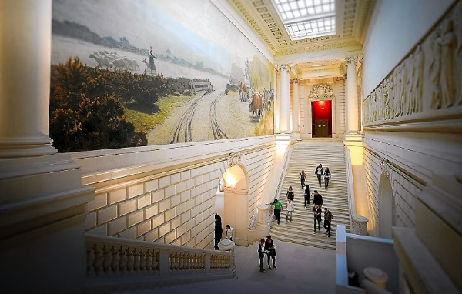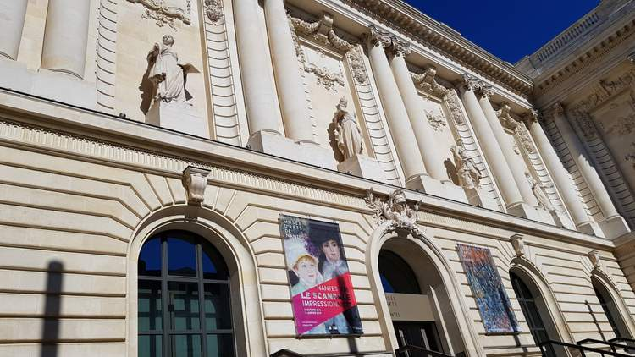

**10 Rue Georges Clemenceau, 44000 Nantes** ([Map](https://www.google.com/maps/place/Mus%C3%A9e+d'arts+de+Nantes/@47.219658,-1.5496297,17z/data=!3m1!4b1!4m5!3m4!1s0x4805eebc6f4d82f1:0x263a3cac2b4a5342!8m2!3d47.219658!4d-1.547441))

By tram Line 1, ‘Duchesse-Anne’ stop, then a 10-minute walk

Line 2, ‘St Mihiel’ stop, then a 10-minute walk

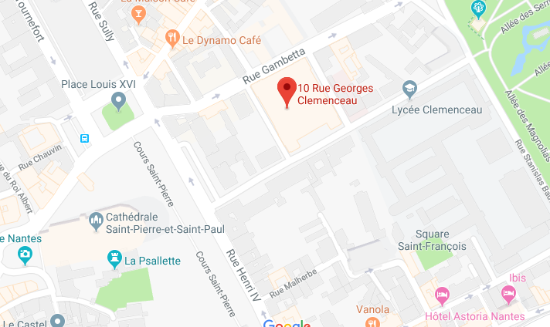

|  |  |
| --- | --- |
| **19:00** | Visit of the museum |
| **19:45 - 22:00** | Cocktail |

**To reach Vertigo – Restaurant & Sky bar**

(Friday, May 24, 19:30 – 22:30)

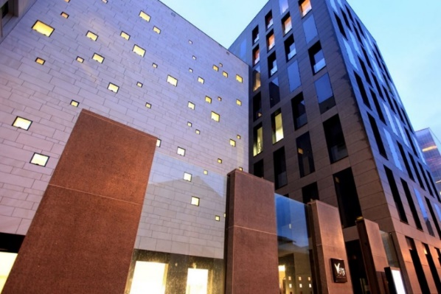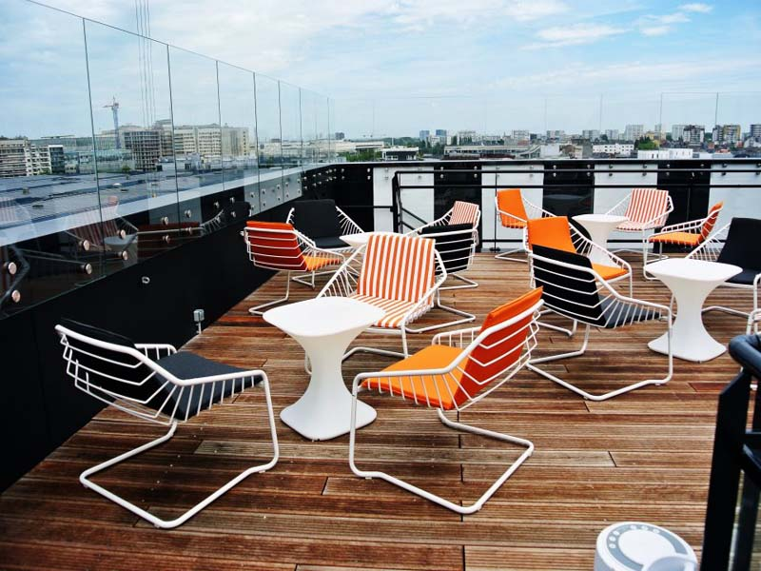

**3 Mail du Front populaire, 44200 Nantes** ([Map](https://www.google.com/maps/place/Vertigo+Restaurant/@47.2098608,-1.5662295,16z/data=!4m5!3m4!1s0x4805ec01a8c71b39:0x55df39eec3fb46b5!8m2!3d47.2066795!4d-1.5629036))

By tram Line 1, ‘Chantiers Navals’ stop, then a 7-minute walk

Line 2, ‘Commerce’ stop, then a 18-minute walk

